**WT ASSIGNMENT**

**NAME-SANYA VERMA**

**SECTION-BCA(AI-ML)1B**

**ROLL NO-24SCA/BCA(AIML)060**

Q1= Create a simple html tag using basic tags?

<HTML>

<HEAD>

<TITLE> HELLO WORLD </TITLE>

</HEAD>

<body>

<H1> HELLO WORLD </h1>

</Body>

</html>

Output:

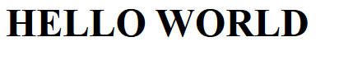

Q2= **Create a web page that displays your name to the screen?**

Ans=<HTML>

<HEAD>

<body>

<H1> SANYA VERMA </h1>

</body>

</html>

OUTPUT:



**Q3= Create a web page and show the output from 1 to 10 in separate lines?**

<HTML>

<HEAD>

<TITLE> HELLO WORLD </TITLE>

</HEAD>

<body>

1<br> 2<br> 3<br> 4<br> 5<br> 6<br> 7<br> 8<br> 9<br> 10<br>

</body>

</html>

output: 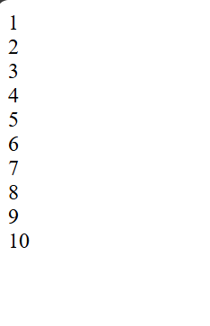

**Q4= Create a webpage and show the output from 1 to 10 in separate lines, each number being in different color?**

<HTML>

<HEAD>

<TITLE> HELLO WORLD </TITLE>

</HEAD>

<body>

<font color="blue"> 1 </font><br>

<font color="red"> 2 </font><br>

<font color="yellow"> 3 </font><br>

<font color="black"> 4 </font><br>

<font color="brown"> 5 </font><br>

<font color="pink"> 6 </font><br>

<font color="orange"> 7 </font><br>

<font color="purple"> 8 </font><br>

<font color="grey"> 9 </font><br>

<font color="green"> 10 </font><br>

</body>

</html>

output: 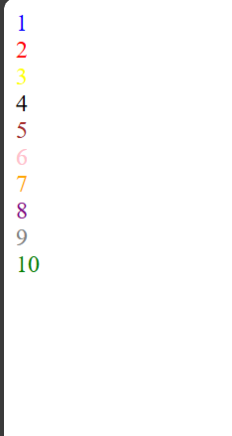

**Q5= how to make a picture as a background on my web pages?**

ANS= <HTML>

<HEAD>

<TITLE> HELLO WORLD </TITLE>

</HEAD>

<body>

<body background="C:\Users\91931\Desktop.jpg">

</body>

</html>

output



**Q6=Create a web page to print a paragraph with 4-5 sentences, each sentences shall have a different font?**

**Ans:**

<html>

<body>

<h1>Introduction</h1>

<P>

<B>My name is Sanya Verma. </B><br>

<I>I am studying in MIIRS. It is situated in

Faridabad, HARYANA. </I>

<br> <U> My course that i am pursuing right now is BCA(AI/ML) </U>.

<br><B> My Hobbies are reading and watching movies and series.</B><br>

</p>

</body>

</html>

OUTPUT:

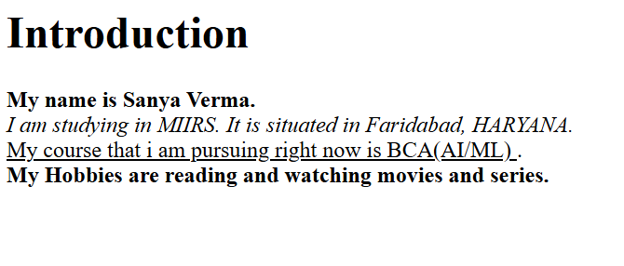

**Q7=write HTML code to print a paragraph that is described of a book, it shall include the title should be underlined and all adjectives shall be bold and italics?**

<HTML>

<Body>

<H1><u><b><font color="red"> Title of The Book:THE DA VINCI CODE </font></b></u></H1>

<p><b> Author Name: DAN BROWN </b><br>

<i>***The Da Vinci Code*is a 2003**[**mystery**](https://en.wikipedia.org/wiki/Mystery_(fiction))[**thriller novel**](https://en.wikipedia.org/wiki/Thriller_(genre))**by**[**Dan Brown**](https://en.wikipedia.org/wiki/Dan_Brown)**. It is Brown's second novel to include the character**[**Robert Langdon**](https://en.wikipedia.org/wiki/Robert_Langdon)**: the first was his 2000 novel**[***Angels & Demons***](https://en.wikipedia.org/wiki/Angels_%26_Demons)**.*The Da Vinci Code*follows**[**symbologist**](https://en.wikipedia.org/wiki/Symbologist)**Langdon and**[**cryptologist**](https://en.wikipedia.org/wiki/Cryptography)**Sophie Neveu after a murder in the**[**Louvre Museum**](https://en.wikipedia.org/wiki/Louvre_Museum)**in Paris entangles them in a dispute between the**[**Priory of Sion**](https://en.wikipedia.org/wiki/Priory_of_Sion)**and**[**Opus Dei**](https://en.wikipedia.org/wiki/Opus_Dei)**over the possibility of**[**Jesus**](https://en.wikipedia.org/wiki/Jesus)**and**[**Mary Magdalene**](https://en.wikipedia.org/wiki/Mary_Magdalene)**having had a child together.**

**The novel explores an alternative religious history, whose central plot point is that the**[**Merovingian**](https://en.wikipedia.org/wiki/Merovingian_dynasty)[**kings of France**](https://en.wikipedia.org/wiki/List_of_French_monarchs)**were descended from**[**the bloodline of Jesus Christ**](https://en.wikipedia.org/wiki/Jesus_bloodline)**and Mary Magdalene, ideas derived from Clive Prince's**[***The Templar Revelation***](https://en.wikipedia.org/wiki/The_Templar_Revelation)**(1997) and books by**[**Margaret Starbird**](https://en.wikipedia.org/wiki/Margaret_Starbird)**. The book also** refers to[*The Holy Blood and the Holy Grail*](https://en.wikipedia.org/wiki/The_Holy_Blood_and_the_Holy_Grail)(1982), though Dan Brown has stated that it was not used as research material.

</i></P>

</p></body></html>

OUTPUT: 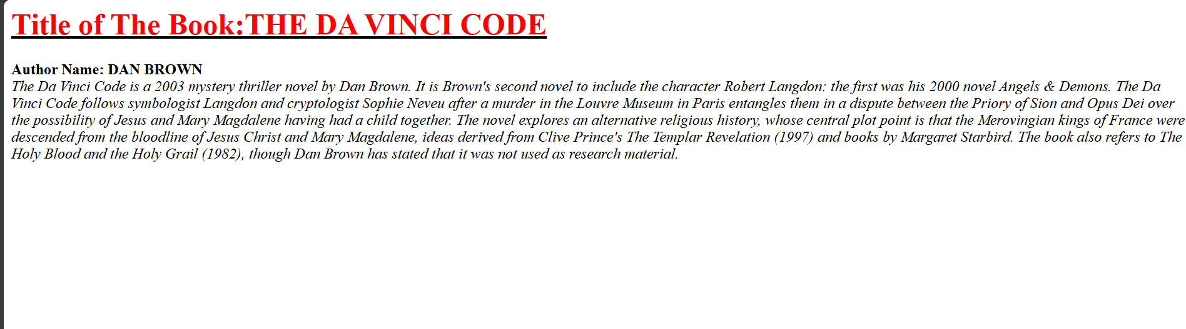

**Q8: Write HTML code to print your name using heading tag, every letter shall be of different heading size?**

**<HTML>**

**<BODY>**

**<H1> S</h1>**

**<H2> A</h2>**

**<H3> N</h3>**

**<H4> Y</h4>**

**<H5> A</h5><br>**

**<H1> V</h1>**

**<H2> E</h2>**

**<H3> R</h3>**

**<H4> M</h4>**

**<H5> A</h5><br>**

**</body>**

**</html>**

**output:**



**Q9: Write Html code to print the sequence of number 1-20. each no shall be in different line with number 2 next to it as subscript, an equal sign and the result?**

**Ans:** <html>

<head>

<title>Number Sequence</title>

</head>

<body>

<p>1<sub>2</sub> = 1</p>

<p>2<sub>2</sub> = 4</p>

<p>3<sub>2</sub> = 9</p>

<p>4<sub>2</sub> = 16</p>

<p>5<sub>2</sub> = 25</p>

<p>6<sub>2</sub> = 36</p>

<p>7<sub>2</sub> = 49</p>

<p>8<sub>2</sub> = 64</p>

<p>9<sub>2</sub> = 81</p>

<p>10<sub>2</sub> = 100</p>

<p>11<sub>2</sub> = 121</p>

<p>12<sub>2</sub> = 144</p>

<p>13<sub>2</sub> = 169</p>

<p>14<sub>2</sub> = 196</p>

<p>15<sub>2</sub> = 225</p>

<p>16<sub>2</sub> = 256</p>

<p>17<sub>2</sub> = 289</p>

<p>18<sub>2</sub> = 324</p>

<p>19<sub>2</sub> = 361</p>

<p>20<sub>2</sub> = 400</p>

</body>

</html>

Output:

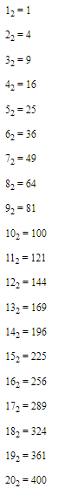

Q10. wtrite an html code to display an image with border of size with width 200 height 200 pixels, leaving Hspace and Vspace of your choice with image hanging in the right side on the screen.

Ans: <HTML>

<head>

<title>Image Display</title>

<style>

img {

border: 2px solid black;

width: 250px;

height: 250px;

display: block;

margin-left: auto;

margin-right: 0;

margin-top: 20px;

margin-bottom: 20px; }

</style>

</head>

<body>

<img src="C:\Users\91931\Desktop/ sanya download.jpg " alt="Sample Image">

</body>

</html>

output:

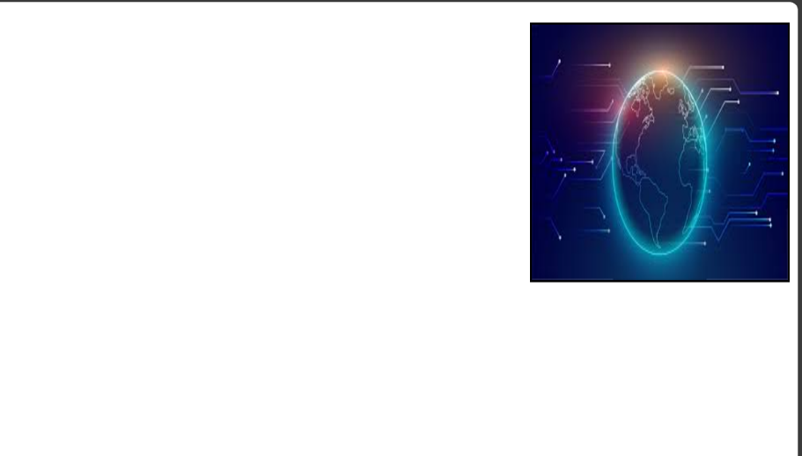

Q11: write a html code to create a web page with heading. the heading shall be displayed at the top-centre of the page and the image shall be at the centre, just below the heading.

Ans: <html>

<body>

<center>

<h1>The Island</h1>

<img src="C:\Users\91931\Desktop/sanya download.jpg” alt="scenery" height="450" width=”450” >

</center>

</body>

</html>

output:



Q12. Write HTML code using Multimedia tags.

<html>

<body> <center>

<h1> multimedia tags: </h1>

<h1>img</h1>

<img src="C:\Users\91931\Desktop/sanya download.jpg" alt="scenery" height="350" width="350"/>

<h1> audio </h1>

<audio src="C:\Users\91931\Downloads/music.mp3" controls/>

<center> </body>

</html>

output:

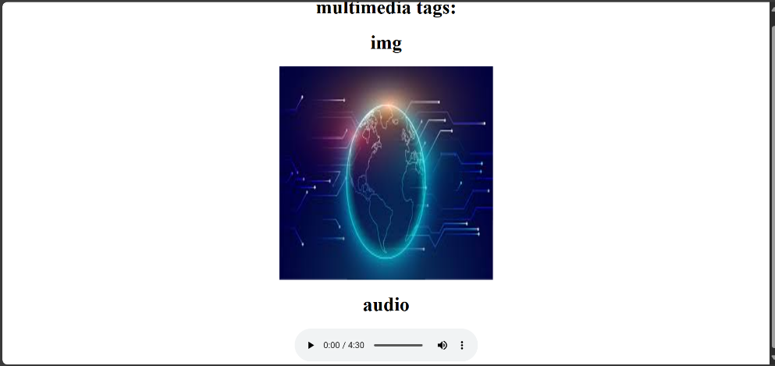

**Q13:****Create a Table using Rowspan and Colspan taking example of student Record?**

**rowspan**

<html>

<body>

<h1> table </h1>

<table border="1">

<tr>

<th> name</td>

<th> Class</td>

</tr>

<tr>

<td >Sanya</td>

<td rowspan="2">1B</td>

</tr>

<tr>

<td> Monika</td>

</tr>

</table>

</body>

</html>

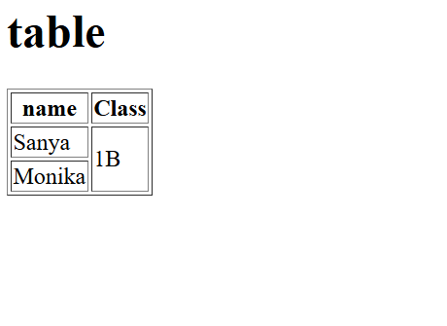

colspan:

<html>

<body>

<h1> table </h1>

<table border="1">

<tr>

<th> name</td>

<th> roll no</td>

<th> class</th>

</tr>

<tr>

<td >sanya</td>

<td colspan="2">60</td>

</tr>

<tr>

<td>monika</td>

<td>41</td>

<td> bca </td>

</tr>

</table>

</body>

</html>

output:

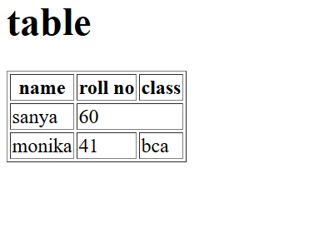

**Q14: Write HTML code using table tag <table> and cellpadding and cellspacing as its attributes**?

<html>

<head>

<style>

table, th, td {

padding : 15;

Spacing : 15;

}

</style>

</head>

<body>

<table border="1">

<tr>

<th> Name </th>

<th> Class </th>

<th> Roll No. </th>

</tr>

<tr>

<td> sanya</td>

<td> 1B </td>

<td> 60 </td>

</tr>

<tr>

<td> monika </td>

<td> 1B </td>

<td> 41 </td>

</tr></table>

</body>

</html>

output:

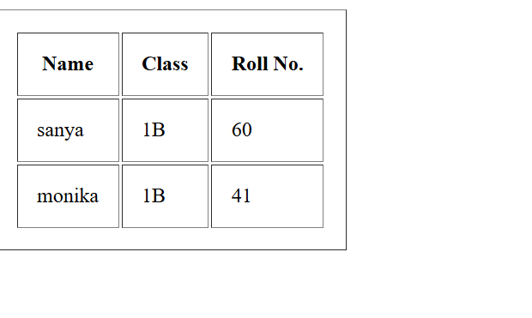

Q15: Create unordered, ordered and definition Lists taking example of your subjects in MCA IST, IInd and IIIrd Semester?

<html>

<head>

<body>

<ul>MCA FIRST YEAR

<li>computer architecture</li>

<li>descrete maths</li>

<li>problem solving using c C</li>

<li>fundamentals of computers</li>

</UL>

<OL>MCA 2ND YEAR

<li>systems software</li>

<li>software engineering</li>

<li>tqm</li>

</ol>

<dl>IIIrd SEMESTER

<DT>Artifial intelligence</dt>

<dd>Artificial intelligence (AI) refers to computer systems capable of performing complex tasks that historically only a buruan could do, such as reasoning, making decisions, or solving proble</dd>

<dt>Compiler designs</dt>

<dd>The compiler is software that converts a program written in a high-level language (Source Language) to a low-lev sanguage (Object Tanges Machine Language Software Engineering</dd>

<dt>Software engineering</dt>

<dd>Software Engineering is the process of designing, developing, testing, and maintaining softyware. It is a systematic and disciplined approach to software development that sans to coure lich quên and maintainable software</dd>

</Dl>

</body>

</HEAD>

</html>

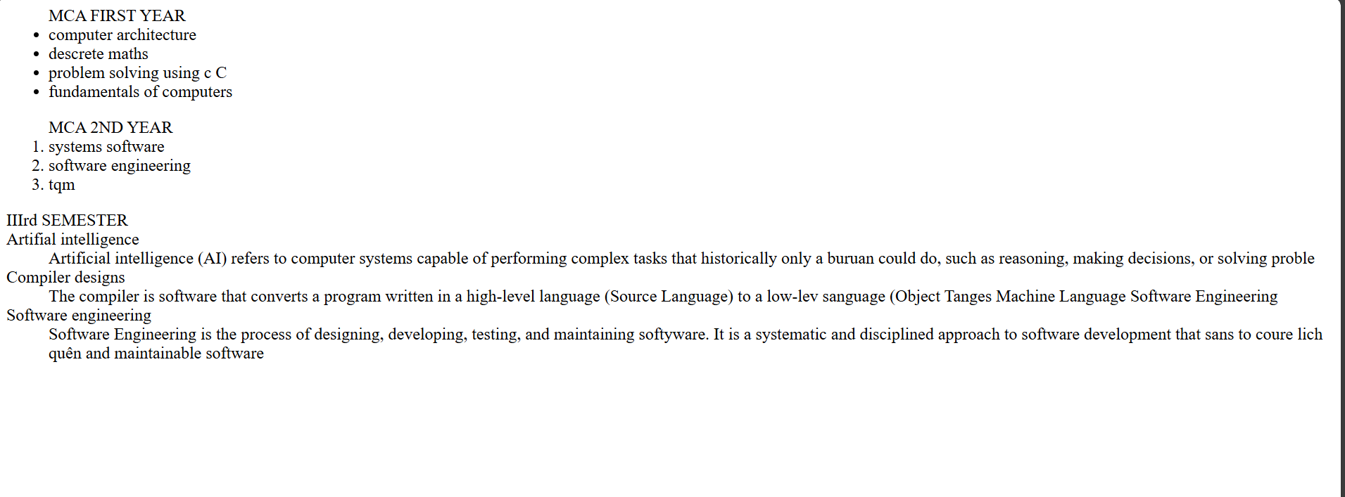

Q17: Write HTML code to design a form in HTML using controls and buttons such as Textbox, Text area, password, submit button, browse button, drop-down menu?

Ans: <html>

<body>

<h1> FORM </h1>

<fieldset>

<label for="name">Name:</label>

<input type="text" id="name" name="name" required/>

<br><br>

<label for="name">Name:</label>

<input type="text" id="name" name="name" required/>

<br><br>

<label for="Password">Password:</label>

<input type="Password" id="Password" name="Password" required/>

<br><br>

<label for=”file">File</label>

<input type="file" id=" file " name=" file " required/>

<br><br>

<h3> text area</h3>

<textarea cols="50" rows="5"/></textarea><br><br>

<button type="submit">Submit</button>

<button type="reset">Reset</button><br><br>

<select id="subjects" name="subjects">

<option value="wt" id="subjects" name="subjects">wt</option>

<option value="Dbms" id="subjects" name="subjects">Dbms</option>

<option value="ITPC" id="subjects" name="subjects">ITPC</option>

</select>

</fieldset>

</form>

</body>

</html>

output:

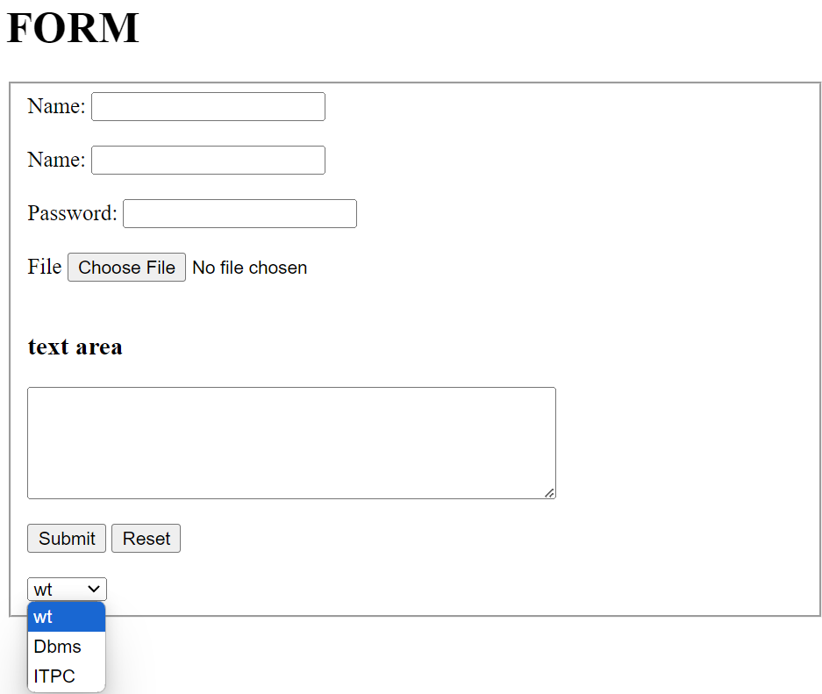

Q18: Write HTML code to design a Registration Form in HTML?

Ans: <html>

<head>

<title> Form </title>

</head>

<body>

<h1>FORM</h1>

<form>

<fieldset>

<legend><b>REGISTRATION FORM</b></legend>

<label for="fname" id=name><b>Name:</label><br>

<input type="text" required>

<label for="12th Marks" id="name"><b> 12th Marks (%): </b></label>

<input type="number" max="100" min="33" required/>

<b> Upload here</b>

<input type="file"/><br>

<label for="Email" id=name required>Email:</label><br>

<input type="Email"/>

<label for="10th Marks" id="name" required ><b>10th Marks (%): </b></label>

<input type="number" max="100" min="33"/>

<b> Upload here</b>

<input type="file" name="mark sheet"/><br>

<label for="Name" id=name>Father's Name:</label><br>

<input type="text"/>

<font color="red">Character certificate</font>

<input type="file" required/><br>

<label for="Course Name" id=name>Course Name:</label><br>

<input type="text"/>

<font color="red">Migration certificate</font>

<input type="file"/><br><br>

<b>Phone No:</b>

<input type="text" size="9" maxlength="10" required/>

<b><u> gender</u></b><br>

<input type="radio" name="gender"/>

<label for="gender" name="gender">Male</label>

<input type="radio" name="gender"/>

<label for="gender" name="gender">female</label>

<input type="radio" name="gender"/>

<label for="gender" name="gender">others</label><br>

<b><u>Subject</u></b><br>

<input type="Checkbox"/>

<label for="Subject" name="subject">Wt</label>

<input type="Checkbox"/>

<label for="Subject" name="subject">Dbms</label>

<input type="Checkbox"/>

<label for="Subject" name="subject">ITPC</label>

<input type="Checkbox"/>

<label for="Subject" name="subject">Eng</label>

<input type="Checkbox"/>

<label for="Subject" name="subject">History</label><br>

<lable for="date" name="birth">DOB:</lable>

<input type="date" max="2007" min="2003" required/><br><br>

<lable for="date" name="birth">Date of joining</lable>

<input type="month" id="joining" required/><br>

<br>

<button>Submit</button>

</fieldset>

</form>

</body>

</html>

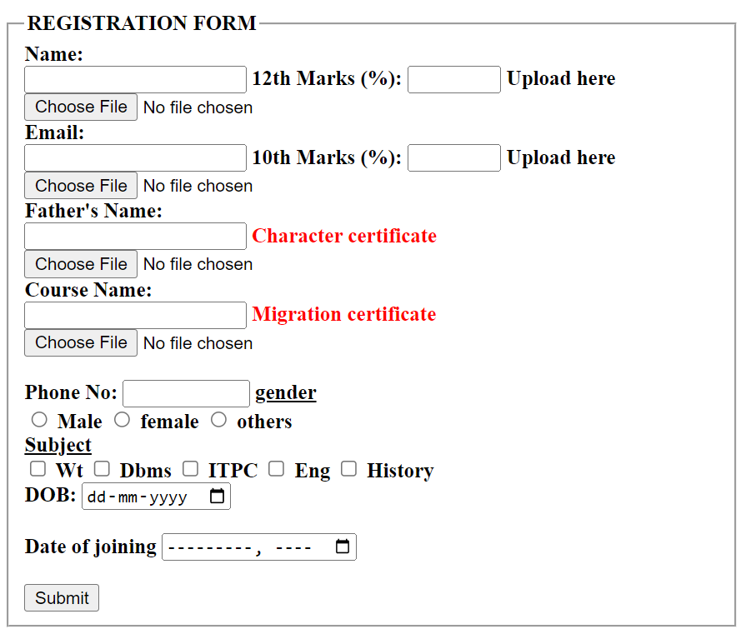

Q19. Write HTML code to design a student admission Form in HTML?

Ans: <html>

<head>

<title> Form </title>

</head>

<body>

<h1>FORM</h1>

<form>

<fieldset>

<legend><b>ADDMISSION FORM</b></legend>

<label for="fname" id=name><b>Name:</label><br>

<input type="text" required>

<label for="12th Marks" id="name"><b> 12th Marks (%): </b></label>

<input type="number" max="100" min="33" required/>

<b> Upload here</b>

<input type="file"/><br>

<label for="Email" id=name required>Email:</label><br>

<input type="Email"/>

<label for="10th Marks" id="name" required ><b>10th Marks (%): </b></label>

<input type="number" max="100" min="33"/>

<b> Upload here</b>

<input type="file" name="mark sheet"/><br>

<label for="Name" id=name>Father's Name:</label><br>

<input type="text"/>

<font color="red">Character certificate</font>

<input type="file" required/><br>

<label for="Course Name" id=name>Course Name:</label><br>

<input type="text"/>

<font color="red">Migration certificate</font>

<input type="file"/><br><br>

<b>Phone No:</b>

<input type="text" size="9" maxlength="10" required/>

<b><u> gender</u></b><br>

<input type="radio" name="gender"/>

<label for="gender" name="gender">Male</label>

<input type="radio" name="gender"/>

<label for="gender" name="gender">female</label>

<input type="radio" name="gender"/>

<label for="gender" name="gender">others</label><br>

<b><u>Subject</u></b><br>

<input type="Checkbox"/>

<label for="Subject" name="subject">Wt</label>

<input type="Checkbox"/>

<label for="Subject" name="subject">Dbms</label>

<input type="Checkbox"/>

<label for="Subject" name="subject">ITPC</label>

<input type="Checkbox"/>

<label for="Subject" name="subject">Eng</label>

<input type="Checkbox"/>

<label for="Subject" name="subject">History</label><br>

<lable for="date" name="birth">DOB:</lable>

<input type="date" max="2007" min="2003" required/><br><br>

<br>

<button>Submit</button>

</fieldset>

</form>

</body>

</html>

OUTPUT:

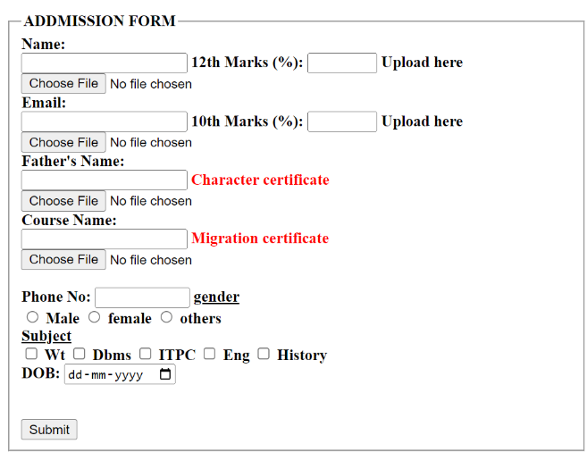

Q20: Create a proper home page of your own using any components and styles?

ANS- <html>

<head>

<style>

/* different styles of heading */

H1, h2, h3 {

text-align: center;

color: BLUE;

}

#para1 {

text-align: center;

color: green;

font-size:15;

}

.center{text-align: center;

color:RED;

font-size:25;

font-family: sans-serif;

}

</style>

</head>

<body bgcolor="green">

<H1>WEB TECHNOLOGIES APPLICATIONS</h1>

<h2> Efficient,Work Better,Cheap </h2>

<p class="center"> USE WEB TECHNOLOGIES APPLICATION IN YOUR PC</p>

<hr>

</body>

</html>

OUTPUT:

